PROJECT REPORT

ON

# VIRTUAL CANVAS

SUBMITTED BY

Sanika Kale

Rajnandini Kanade

Purva Kirad

Kanishka Khalane

Ketaki Mahamuni

UNDER THE GUIDANCE OF

Ms. Swapnali Londhe

P.E.S.’S MODERN COLLEGE OF ENGINEERING

PUNE – 411 005.



SAVITRIBAI PHULE PUNE UNIVERSITY

2022 - 23

CERTIFICATE

This is to certify that

**Name-Sanika Kale Exam No. F190310531**

**Name-Rajnandini Kanade Exam No. F190310548**

**Name-Purva Kirad Exam No. F190310610**

**Name-Kanishka Khalane Exam No. F190310589**

**Name-Ketaki Mahamuni Exam No**. **F190310682**

F.E (Computer) have successfully completed the project titled ‘**VIRTUAL CANVAs’** during the academic year 2022-2023

**Prof Dr. Mrs K.R.Joshi Prof. Dr. Mrs S.A.Itkar Ms. Swapnali Londhe Principal H.O.D. Project Guide**

**P.E.S.’s MCOE, Pune-5 (Computer Engineering Department) ACKNOWLEDGEMENT**

Acknowledgment for Virtual Canvas Project:

We would like to express our deepest appreciation and gratitude to all those who contributed to the successful completion of the Virtual Canvas Project. This endeavour would not have been possible without the support, dedication, and expertise of numerous individuals and organizations.

First and foremost, we extend our heartfelt thanks to our project team members for their tireless efforts and commitment. Their exceptional skills, creativity, and collaborative spirit have been instrumental in turning the concept of a virtual canvas into a reality. Each team member's unique contributions and unwavering dedication have significantly enriched the project.

We would like to extend our gratitude to our project supervisor and mentors for their guidance and valuable insights throughout the project. Their vast knowledge, experience, and encouragement have been invaluable in shaping the direction and success of the Virtual Canvas Project.

We would also like to thank our technical advisors and experts who provided their expertise and support, ensuring the project's technical feasibility and innovation. Their valuable input and feedback have greatly influenced the development and refinement of the virtual canvas platform.

Furthermore, we express our appreciation to the users and testers who actively participated in the beta testing phase, providing valuable feedback and helping us identify areas for improvement. Their involvement and feedback were crucial in enhancing the user experience and overall functionality of the Virtual Canvas Project. We are grateful to our sponsors and funding organizations for their generous support, which enabled us to acquire the necessary resources, technology, and infrastructure to bring the virtual canvas to life. Their belief in the project's potential and financial assistance were vital in its successful implementation.

Finally, we would like to acknowledge the wider community for their enthusiasm, interest, and support throughout the development process. The valuable conversations, suggestions, and encouragement we received from the community have played a significant role in shaping the Virtual Canvas Project.

To everyone involved, directly or indirectly, in making this project a reality, we extend our heartfelt gratitude. Your contributions, commitment, and belief in the project have been indispensable. The Virtual Canvas Project stands as a testament to the power of collaboration, innovation, and shared vision.

Thank you all for being part of this remarkable journey.

Sincerely,

Sanika Kale, Rajnandini Kanade, Purva Kirad,

Kanishka Khalane, Ketaki Mahamuni

**ABSTRACT**

* The virtual canvas fosters unparalleled interactivity and engagement with the audience. Viewers are no longer passive observers but active participants, invited to explore and interact with the work in immersive and dynamic ways.
* This paper explores the captivating world of air canvas, a unique technique within abstract art that employs airbrushing and fluid mediums to create ethereal and dynamic compositions. The aim of this study is to analyse the characteristics, process, and impact of air canvas as an artistic medium. The virtual canvas enables the integration of sound, motion, and interactivity, captivating the senses and evoking emotional responses in ways that traditional art forms often struggle to achieve.
* By examining the historical background, technical aspects, and artistic significance of air canvas, this paper offers a comprehensive understanding of its transformative power in the realm of abstract art. This three-page paper explores the potential of air canvas as a program-based learning tool, harnessing its unique qualities to foster creativity and engagement among learners.
* Air canvas, a technique within abstract art that utilizes airbrushing and fluid mediums, offers a dynamic and innovative approach to education. This study aims to provide an overview of the characteristics, implementation strategies, and benefits of integrating air canvas into program-based learning.
* By examining its pedagogical value, hands-on experiences, and interdisciplinary applications, this paper offers insights into how air canvas can enhance the learning experience, promote critical thinking, and cultivate artistic expression.
* Virtual Canvas has been one of the most fascinating and interesting research areas in the field of gesture recognition. Writing is an integrated form of communication that can convey our thoughts. This project focuses on development of Virtual Canvas, an advanced step towards communication using computing processes to recognise human gestures using mathematical algorithms and track the finger movements to achieve this feat.
* The purpose of the study is to discuss the usage of computer vision in educational applications. In recent years, air writing has become one of the most challenging and exciting research areas in image processing and pattern recognition. Typing and writing are standard ways to record information today. Letters or words are written in a relaxed space by marker or finger.
* A computing process that attempts to recognize and interpret human gestures through the use of mathematical algorithms is known as gesture recognition. To track finger movement, the application will employ computer vision. Other uses for the created text include sending emails and texts, among others. It will be a helpful means of communication for the deaf, specially- abled, senior citizens and children for educational purposes.
* The project employs object tracking techniques to construct a motion-to-text converter that might be used as software in the field of education to allow students and teachers to write in the air.
* The project generates letters on the screen by utilizing computer vision to trace the path of a finger or an object. The resulting text can be utilized for a variety of things, including solving graph-related challenges. Questions on logical reasoning (Mathematics), to write formulas or execute derivations, Kindergarten kids are being taught the alphabet, to replace chalk and board (dustless classroom) in offline classes, etc. For the deaf, it will be a strong way of communication.
* The material and presenting it on screen using the applications is the part of interaction that is possible through Air Canvas. Having various colours present is also part of this interaction. The varied colour schemes make it easier for the user to identify things and provide greater clarity.
* Accessing the built in web camera on the laptop or independent web camera that was installed is required to accomplish this. This contributes to a better overall knowledge and provides the user with a more concise description of the air. In addition to that, this is utilised for text visualisation and drawing for audience.
* This has the potential to serve as a stepping stone for more innovative streams and materials that is engaging in the future. Simply moving your finger through the air will allow you to draw creative ideas, which does make use of computer vision technology.
* In the respective paper, we construct a screen through which the information or text that we draw by waving is displayed appropriately on the screen for which is done by employing shooting the motion of finger using internet digital camera. This is accomplished in a manner similar to how a touch screen works.
* The detection of the colours, tracking of marker, and establishment of co-ordinates are the objectives of this particular piece of writing.

**TABLE OF CONTENTS**

Sr. No. Page No.

1. Introduction 7
2. Literature Survey 9
3. Specification of the project 11
4. Block diagram & description 12
5. Software System Design 13

(Algorithms & Flowchart)

1. Results and Performances Evaluation 15
2. Applications & Future Modifications 16
3. Conclusion 18
4. Reference/Bibliography 19

**1. Introduction**

The introduction provides a concise overview of the significance and influence of abstract art as a distinct artistic genre. It highlights the emergence of abstract art as a radical departure from representational forms, emphasizing the freedom of expression and non-objective nature that characterizes this movement. It also introduces the concept of air canvas as a unique technique within abstract art that pushes the boundaries of creativity and explores the interplay between fluidity and control. The introduction introduces the concept of program-based learning and its significance in fostering interdisciplinary skills and knowledge acquisition. It highlights the need for innovative and engaging approaches to education, and how incorporating artistic practices can enhance student learning outcomes. The background section provides a brief overview of air canvas as a technique within abstract art, emphasizing its potential to captivate learners and foster creativity

The Air Canvas Report provides an in-depth analysis and evaluation of the emerging technology known as Air Canvas, which has revolutionized the way we interact with digital content. Air Canvas is a groundbreaking innovation that combines augmented reality (AR) and touchless gestural interfaces to create a virtual canvas in mid-air, enabling users to manipulate and interact with digital content using intuitive hand gestures.

In this report, we aim to explore the various aspects of Air Canvas, including its origins, underlying technology, applications across different industries, potential benefits and challenges, and its impact on the future of human-computer interaction. By examining these factors, we seek to provide a comprehensive understanding of Air Canvas and its implications for various fields, such as education, design, entertainment, and more.

The report begins with an overview of the concept of Air Canvas, delving into its historical background and the technological advancements that have made it possible. We then delve into the underlying technology, exploring how Air Canvas combines AR and touchless gestural interfaces to create an immersive and interactive experience. We examine the key components, tracking systems, and software algorithms that enable the seamless interaction between users and digital content.

Furthermore, the report highlights the diverse range of applications for Air Canvas across different industries. We discuss how Air Canvas is transforming the way we learn and teach, revolutionizing the design and creative processes, enhancing immersive entertainment experiences, and even finding applications in healthcare and industrial sectors.

As we explore the potential benefits of Air Canvas, we consider its impact on user experience, productivity, and creativity. We analyse how this innovative technology promotes intuitive and natural interactions, eliminates physical barriers, and enhances collaboration, thereby unlocking new possibilities for human expression and communication.

However, it is crucial to acknowledge the challenges and limitations associated with Air Canvas. The report discusses the technical hurdles, such as hardware requirements and accuracy of gesture recognition, as well as potential privacy and security concerns that arise with the integration of AR and touchless interfaces.

OpenCV (Open Source Computer Vision) - is a programming language library consisting of different types of functions mainly for computer vision. To explain in a simple language or in general way it is a library used for Image Processing. It is used mainly to do all the operations which are related to Images. What it can do: 1. Read and Write Images. 2. Detection of faces and its features. 3. Detection of different shapes such as circle, rectangle etc in an image. E.g Detection of coins in images. 4. Text recognition in images. e.g Reading Number Plates. 5. Can modify the quality of an image or it's colour. 6. Developing Augmented reality app

OpenCV has been re-architected from C to modern, modular C++ compatible with STL and Boost. The library has been brought up to modern software development standards with distributed development on Git.

OpenCV is a library for images. It roughly supports all main programming languages. Commonly used in python and C++. OpenCv can be used to read or write an image, for image modification. Convert coloured to gray, binary, HSV etc. OPENCV is also an OPEN SOURCE.

With the help of NumPy, one can generate random pattern textures or shapes on the virtual canvas by just using random number generation functions which can be useful for tasks like data augmentation or generative art.

The user interface of a virtual canvas is designed to mimic traditional art supplies and techniques.

It often includes a drawing area where users can directly interact intract with the canvas without using digital mouse, stylus or touch screen

Many virtual canvases aim to replicate the look and feel of traditional art mediums, such as oil paint, watercolour, charcoal or pencil. They offer different textures and colours that stimulate the behaviour and characteristics of the physical materials..

Python programming is used for developing the virtual mouse system, and also, the library for computer vision that is OpenCV is used in the AI virtual mouse system. In the proposed system, the model uses the MediaPipe package for the tracking of the hands and for tracking the tip of the fingers, also, Pynput, Autopy, and PyAutoGUI packages are used for moving around the window screen of the computer for performing various functions such as left click, right click, and scrolling functions. The results of the proposed AI virtual mouse model showed very high accuracy level, and the model can work very well in real-world application with the use of a CPU without the us e of a GPU

As a conclusion, the virtual canvas enables creation of interactive applications wherein user can draw, annotate or manipulate images in real time without using mouse or any other mechanical electronic device just by empowering individuals without coding expertise to unleash their creativity and express their ideas visually by user friendly interface

**2. Literature Survey**

|  |  |  |
| --- | --- | --- |
| Sr. No. | Researcher Name | Work |
| 1 | Shomi Khan, M. Elieas Ali], Shree Sourav Das | a skin colour identification algorithm to translate American Sign Language (ASL) from real-time video into text. It could be difficult to identify the hand because skin tone and hand form vary from person to person. The technology uses two neural networks to overcome this. The SCD (Scalable colour descriptor) neural network is the first algorithm. The picture pixels are fed into the SCD neural network, which determines whether or not they are skin pixels. The second is HGR (Hand gesture recognition) neural network in which the extracted features will be added. The features are to be extracted by two distinct algorithms namely Finding the fingertip and Pixel segmentation algorithm. [1] |
| 2 | S. Belgamwar and S. Agrawal | To accomplish mouse actions such as moving the cursor, clicking left and clicking right with hand gestures, an impalpable interface is conceived and implemented utilizing computer-vision-based real-time dynamic hand gestures. MATLAB is used for the implementation of the system. Researcher have collaboratively developed a new HCI technique that inculcates a camera, an accelerometer, a pair of Arduino microcontrollers and an Ultrasonic Distance Sensors. The main concept behind this interface is to capture motions using Ultrasonic Distance Sensors. To record the gestures, the distance between the hand and the distance sensor is determined. [2] |
| 3 | Pavitra Ramasamy and Prabhu G | By simply waving their finger over an LED light source, the user can create the alphabet or type anything they wish, according to a new technology put forth by the researchers. [3] |
| 4 | Quentin De Smedt, Hazem Wannous, and Jean -Philippe Vandeborre | To extract the movement of the finger sketching the alphabet, only the colour of the LED is tracked. The background is black, and the tracked object's colour is converted to white. The user wanted to draw an image of the alphabet in black and white, so they stitched together several black and white frames to make it. For 3D hand gesture detection, researchers used a skeleton based model. They used the geometric shape of hand to gsin an effective descriptor from the Intel RealSense depth camera's hand skeleton linked joints. The skeleton-based approach is far more better than the depth based approach. [4] |
| 5 | Prajakta Vidhate, Revati Khadse and Saina Rasal | Researchers have developed a virtual paint application that uses ball-tracking technology to track the hand movement and write on the screen. They have used a glove with a ping-pong ball attached to it as a contour.[5] |
| 6 | Ruimin Lyu, Yuefeng Ze, Wei Chen, and Fei Chen | Researchers demonstrated an airbrush model that is easily adaptable and that employs the Leap Motion Controller, which tracks hands, to produce an immersive freehand painting experience. [6] |

The development of Air Canvas involves contributions from various individuals and organizations. While it is challenging to provide an exhaustive list, here are some key stakeholders who have played significant roles in the development of Air Canvas:

1. Researchers and Inventors: The initial development of Air Canvas can be attributed to researchers and inventors who explored the concept and pioneered its implementation. These individuals may include engineers, scientists, and technologists with expertise in areas such as interactive technologies, computer vision, and human-computer interaction.

2. Technology Companies and Startups: Several technology companies and startups have been involved in the development and commercialization of Air Canvas. These organizations invest in research and development, design the hardware and software components, and bring the technology to market. Examples of such companies include those specializing in virtual reality (VR), augmented reality (AR), interactive displays, and haptic devices.

3. Academic Institutions: Universities and research institutions often contribute to the advancement of Air Canvas through academic research, collaborations, and projects. Professors, researchers, and students may conduct studies, experiments, and prototypes to explore the capabilities and applications of Air Canvas in various fields.

4. Artists and Designers: Artists and designers have been instrumental in exploring the creative potential of Air Canvas. They contribute their expertise, insights, and feedback to shape the development of Air Canvas as a tool for artistic expression, digital painting, and interactive installations.

5. User Communities and Feedback: Users who engage with Air Canvas provide valuable feedback, suggestions, and requirements that help refine and improve the technology. This includes educators, students, artists, and professionals who actively use Air Canvas in their work and provide insights into its usability, features, and potential enhancements.

It's important to note that the development of Air Canvas is a collaborative effort involving a diverse range of individuals, organizations, and communities, and the specific contributors may vary based on the specific implementation and context of Air Canvas.

**3. Specifications of The Project**

1. Tracking Technology: Air Canvas utilizes advanced tracking technology to accurately detect and track hand movements and gestures in real-time. This can involve the use of depth cameras, infrared sensors, or a combination of both.

2. Gesture Recognition: Air Canvas employs sophisticated algorithms for gesture recognition, allowing users to interact with digital content using intuitive hand gestures. These algorithms interpret and translate hand movements into specific commands or actions within the virtual canvas.

****3. Virtual Canvas Size: Air Canvas provides users with a virtual canvas or space in mid-air, where they can draw, manipulate, and interact with digital content. The size of the virtual canvas can vary depending on the hardware and implementation, ranging from smaller handheld areas to larger, room-scale environments.

4. Resolution and Precision: The resolution and precision of Air Canvas determine the level of detail and accuracy in capturing hand movements and translating them into digital interactions. Higher resolution and precision result in more precise and realistic interactions within the virtual canvas.

5. Compatibility: Air Canvas may be compatible with various devices, platforms, and operating systems. It can be designed to work with smartphones, tablets, PCs, or dedicated AR/VR headsets. The compatibility may extend to popular software and development frameworks, enabling integration with existing applications or creating new ones.

6. User Interface and Interaction Methods: Air Canvas offers intuitive and touchless interaction methods. Users can manipulate digital objects, draw in mid-air, perform gestures for commands, and potentially utilize voice commands or other input modalities to enhance the overall user experience.

7. Integration with Software Applications: Air Canvas can be integrated with various software applications, such as drawing programs, design tools, educational platforms, or interactive entertainment applications. This integration allows users to leverage Air Canvas capabilities within specific domains and contexts.

8. Connectivity and Portability: Air Canvas devices may feature wireless connectivity options such as Bluetooth or Wi-Fi, enabling seamless communication with other devices or networks. Some implementations may prioritize portability, allowing users to use Air Canvas in different locations without significant setup requirements.

9. Battery Life: If Air Canvas relies on battery-powered devices, the battery life becomes an important specification. Longer battery life ensures extended usage and uninterrupted interactions within the virtual canvas.

It's important to note that the specifications mentioned above are general guidelines, and the actual specifications of an Air Canvas system may vary based on the specific product or implementation**.**

**4. Block Diagram and Description**

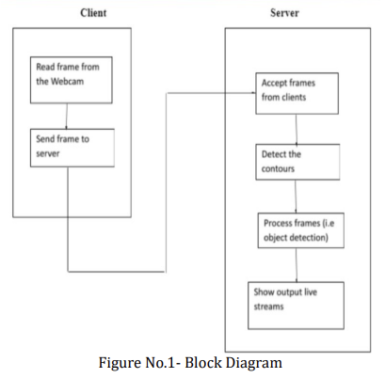

1. Colour Tracking Understanding the HSV (Hue , Saturation , Value ) shading space for Colour Tracking. Furthermore, following the little hued object at fingertip. The approaching picture from the webcam is to be changed over to the HSV shading space for recognizing the hued object at the tip of finger.

2. Trackbars When the trackbars are arrangement, we will get the real time esteem from the trackbars and make range. This reach is a numpy structure which is utilized to be passed in the capacity cv2.inrange(). This capacity returns the Mask on the hued object. This Mask is a high contrast picture with white pixels at the situation of the ideal tone.

3. Contour Detection Recognizing the Position of Coloured item at fingertip and shaping a circle over it. We are playing out some morphological procedure on the Mask, to make it liberated from contaminations and to distinguish shape without any problem. That is Contour Detection.

4. Frame Processing Following the fingertip and drawing focuses at each position for air material impact. That is Frame Processing.

**5.** **Software System Design**

**Algorithm**

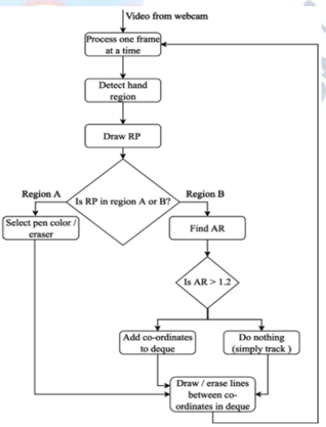

Step1: Start reading the frames and convert the captured frames to HSV colour space. (Easy for colour detection)

Step2: Prepare the canvas frame and put the respective ink buttons on it.

Step3: Adjust the track bar values for finding the mask of coloured marker.

Step4: Preprocess the mask with morphological operations. (Erotion and dilation)

Step5: Detect the contours, find the centre coordinates of largest contour and keep storing them in the array for successive frames. (Arrays for drawing points on canvas)

Step6: Finally draw the points stored in array on the frames and canvas.

**Flowchart**

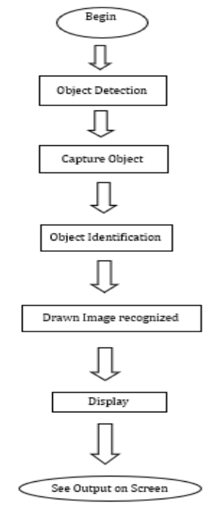

**6.** **Results and Performances Evaluation**

**Results**

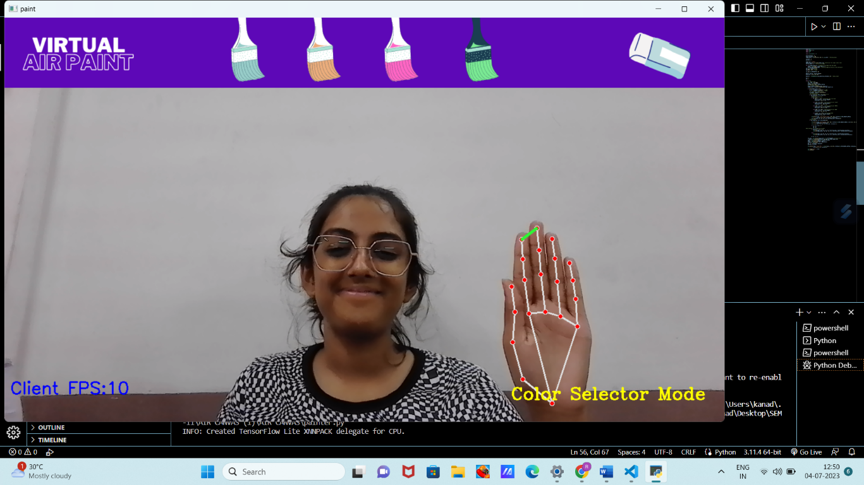

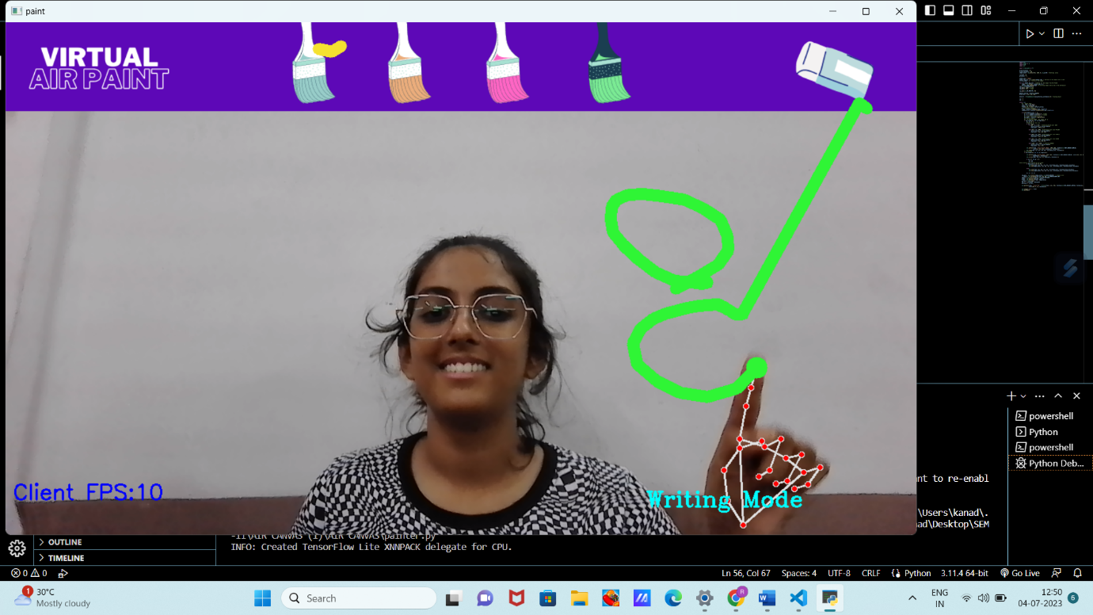**7. Applications and Future Modifications**

**Applications**

Air canvas applications refer to software or mobile applications that allow users to create digital drawings or sketches using touch or stylus input on a device such as a tablet or smartphone. These applications simulate the experience of drawing or painting on a physical canvas, providing various tools and features to enhance the creative process.

Python may be used to quickly analyze photos and videos and extract meaningful information from them, thanks to the many methods provided in OpenCV. Other frequent uses include,

**Image Processing**:

 There are several ways in which the OpenCV may be used to process and interpret images, such as altering their shape, colour, or extracting important information from the supplied picture and writing it into a new image.

**Face Detection**:

By employing Haar-Cascade Classifiers, either from locally recorded videos or photos or from live streaming through web camera.

**Face Recognition**:

In order to identify faces in the films, face identification was performed using OpenCV by generating bounding boxes (rectangles) and subsequently model training using ML methods.

**Object Detection:**

OpenCV and YOLO, an object identification method, may be used to identify moving or stationary objects in images and videos.

**Procreate**: Procreate is a widely used digital illustration app exclusively available for iOS devices. It offers a wide range of brushes, layers, blending modes, and advanced features like pressure sensitivity and customizable shortcuts.

**Autodesk** **SketchBook:** SketchBook by Autodesk is a versatile drawing and painting app available for both iOS and Android. It offers a clean and intuitive interface, a variety of brushes, layer support, and advanced tools like rulers and perspective guides.

**Adobe Photoshop Sketch:** Photoshop Sketch is part of Adobe's suite of creative apps. It is available for iOS and Android and provides a range of brushes and customizable tools. It seamlessly integrates with Adobe Creative Cloud, allowing users to start their artwork on mobile and continue working on the desktop version of Adobe Photoshop.

**Tayasui Sketches**: Tayasui Sketches is a user-friendly drawing app available for iOS. It offers a realistic drawing experience with a variety of brushes, layer support, and tools like blending modes and colour picker.

**Concepts:** Concepts is a flexible drawing and design app available for iOS, Android, and Windows. It combines precision drawing tools with vector manipulation capabilities, making it suitable for sketching, wireframing, and architectural design.

**Future Modification**

The future of air canvas applications holds great potential for further enhancements and modifications. Here are some possible directions for future development:

**1. Improved Realism:** Developers can continue to enhance the realism of air canvas applications by incorporating advanced rendering techniques, such as realistic brush textures, lighting effects, and dynamic simulations for water colour or oil painting.

**2. Augmented Reality (AR) Integration:** With the advancement of augmented reality technology, future air canvas applications could leverage AR capabilities to overlay digital artwork onto the physical world. Users could draw directly on surfaces in their environment, creating a seamless integration of virtual and real-world elements.

**3. Collaboration and Sharing:** Collaboration features can be expanded to enable real-time multi-user drawing sessions, allowing artists to work together remotely on the same canvas. Enhanced sharing options could include the ability to stream or record the creation process, making it easier for artists to showcase their work and engage with their audience.

**4. AI-Assisted Tools:** Artificial intelligence can play a significant role in future air canvas applications. AI algorithms could help in tasks such as automatic colorization, intelligent brush recommendations based on artistic style, or even generating initial sketches or compositions based on user input.

**5. Gesture and Motion Controls:** With the advancement of touch and motion-sensing technologies, future air canvas applications may incorporate more intuitive gesture-based controls. This could include the ability to use hand gestures or even stylus motions in mid-air to control various aspects of the drawing process.

**6. Integration with Other Creative Tools:** Seamless integration with other creative tools and software can enhance the versatility of air canvas applications. This could involve compatibility with 3D modelling and animation software, video editing tools, or integration with cloud storage platforms for easy access and synchronization of artwork across devices.

**7. Customization and Extensibility:** Future air canvas applications could offer more extensive customization options, allowing users to create and import their own brushes, textures, and other creative assets. Extensibility through plugins or scripting interfaces could also empower artists to create their own tools and functionalities within the application.

**8.** **Conclusion**

In conclusion, air canvas applications have transformed the way artists create digital artwork, providing a realistic and intuitive drawing experience on touch-enabled devices. These applications offer a wide range of tools, brushes, and features that simulate the feel of traditional drawing and painting on a physical canvas.

While I have provided examples of popular air canvas applications available as of September 2021, it's important to note that the field is constantly evolving, and new applications with innovative features may have been released since then.

****The future of air canvas applications holds exciting possibilities, including improved realism, augmented reality integration, AI-assisted tools, collaboration and sharing features, gesture and motion controls, integration with other creative tools, and customization options. These advancements aim to enhance the creative process, expand artistic capabilities, and provide artists with more versatile and immersive digital drawing experiences.

As technology continues to advance, we can look forward to even more impressive developments in air canvas applications, empowering artists to explore their creativity and produce stunning digital artwork.

**9. Reference / Bibliography**

[1] S. Khan, M. E. Ali, S. Das and M. M. Rahman, "Real Time Hand Gesture Recog nition by Skin Color Detection for American Sign Language," 2019 4th International Conference on Electrical Information and Communication Technology (EICT), 2019, pp. 1-6, doi: 10.1109/EICT48899.2019.9068809.

[2] Y. Huang, X. Liu, X. Zhang, and L. Jin, "A Pointing Gesture Based Egocentric Interaction System: Dataset, Approach, and Application," 2016 IEEE Conference on Computer Vision and Pattern Recognition Workshops (CVPRW), Las Vegas, NV, pp. 370-377, 2016.

[3] P. Ramasamy, G. Prabhu, and R. Srinivasan, "An economical air writing system is converting finger movements to text using a web camera," 2016 International Conference on Recent Trends in Information Technology (ICRTIT), Chennai, pp. 1-6, 2016.

[4] Q. De Smedt, H. Wannous and J. Vandeborre, "SkeletonBased Dynamic Hand Gesture Recognition," 2016 IEEE Conference on Computer Vision and Pattern Recognition Workshops (CVPRW), 2016, pp. 1206-1214, doi: 10.1109/CVPRW.2016.153.

[5] Prajakta Vidhate, Revati Khadse, Saina Rasal, “Virtual paint application by hand gesture recognition system”, 2019 International Journal of Technical Research and Applications, 2019, pp. 36-39

[6] R. Lyu et al., "A flexible finger-mounted airbrush model for immersive freehand painting," 2017 IEEE/ACIS 16th International Conference on Computer and Information Science (ICIS), 2017, pp. 395-400, doi:10.1109/ICIS.2017.7960025.

 [7] Alper Yilmaz, Omar Javed, Mubarak Shah, "Object Tracking: A Survey", ACM Computer Survey. Vol. 38, Issue. 4, Article 13, Pp. 1-45, 2006

[8] Yuan-Hsiang Chang, Chen-Ming Chang, "Automatic Hand-Pose Trajectory Tracking System Using Video Sequences", INTECH, pp. 132- 152, Croatia, 2010

[9] Erik B. Sudderth, Michael I. Mandel, William T. Freeman, Alan S. Willsky, "Visual Hand Tracking Using Nonparametric Belief Propagation", MIT Laboratory For Information & Decision Systems Technical Report P2603, Presented at IEEE CVPR Workshop On Generative Model-Based Vision, Pp. 1-9, 2004

[10] Kato, H., & Billinghurst, M. (1999). Marker tracking and HMD calibration for a video-based augmented reality conferencing system. In Proceedings of the 2nd IEEE and ACM International Workshop on Augmented Reality (pp. 85-94).

[11] Lee, S. M., Kim, S., & Park, J. I. (2012). Smart air canvas: A depth-sensing pen for three-dimensional interaction with large displays. IEEE Computer Graphics and Applications, 32(1), 56-65.

[12] Yeh, H. C., & Hsieh, H. C. (2013). Study of the interactive whiteboard system with an air-touch canvas. International Journal of Multimedia and Ubiquitous Engineering, 8(6), 71-82.

[13] Song, H. S., Lee, J. W., & Kim, S. W. (2016). Hand gesture-based interaction with smart air canvas for creative design. IEEE Transactions on Industrial Informatics, 12(6), 2217-2225.

[14] Nam, Y., Lee, S., Jung, H., & Woo, W. (2018). AirTouch: Touchscreen-like Interaction on Thin Air Using Airflow Induced by Finger-Motion. In Proceedings of the 2018 CHI Conference on Human Factors in Computing Systems (p. 344).

[15] Gutierrez, M., & Jaureguizar, F. (2018). Virtual air canvas for painting on the air. In Proceedings of the International Conference on Computer Graphics Theory and Applications (GRAPP) (pp. 156-163).

[16] Chen, M., Sun, J., Liu, H., Li, X., & Zhang, Z. (2019). Air Brush: A virtual painting system based on hand motion recognition. In Proceedings of the IEEE Conference on Virtual Reality and 3D User Interfaces (VR) (pp. 1141-1142).

[17] Zong, H., Li, W., Cao, J., Zhang, Y., & Zhang, S. (2021). An Air Gesture Based Input Method for Virtual Canvas in Mobile Virtual Reality. Mobile Information Systems, 2021.